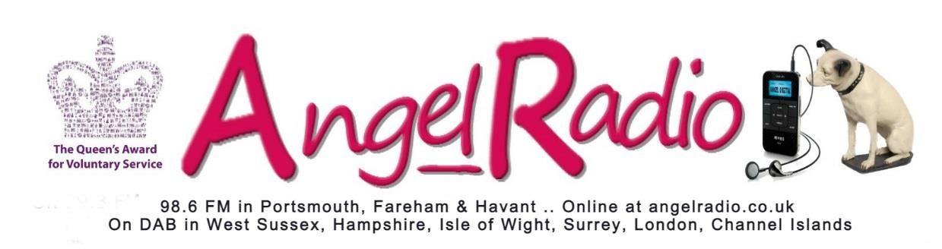
Angel Radio
17 Market Parade
Havant
Hampshire
PO9 1PY

GIFT AID DECLARATION
Angel Radio
Registered Charity No. 1138441

DETAILS OF DONOR
TITLE _________________
FORENAME(S) _____________________________________
SURNAME ________________________________________
ADDRESS _________________________________________
__________________________________________________
__________________________ POST CODE ______________
** Delete as appropriate
** I would like the Charity to treat my donation of £______ and all future donations under the Gift Aid Scheme until I notify otherwise.
**I would like the charity to treat all past donations (since Angel Radio became a charity on 15 October 2010) plus present and future donations under the Gift Aid Scheme until I notify you otherwise.

SIGNED______________________________DATE__________________
NOTES
- You must pay an amount of income tax and/or capital gains tax at least equal to the tax that the charity reclaims on your donation in the past tax year (currently 25p for each £ you give).
- You can cancel this declaration at any time by notifying the charity.
- If in the future your circumstances change and you no longer pay tax on your income and capital gains equal to that tax the charity claims, you can cancel your declaration. (see note 1)
- If you pay tax at the higher rate you can claim further tax relief in your Self-Assessment tax return.
- Please notify the charity if you change your name and/or address.

